**MODUL KULIAH ONLINE (DARING)**

**BAHASA INGGRIS 1 (Basic English Skill)**

**MS NAFIE CLASS**

**MEETING 1**

**Self-Introduction**

**Language Focus:**

**- Self-Introdcution**

**Please Study the following**:

1. Please watch a sample video in this link: <https://www.youtube.com/watch?v=KzQlZFxlusQ>
2. Pay attention to the expressions used in introducing yourself. Here is the list of the most common introduction expressions:

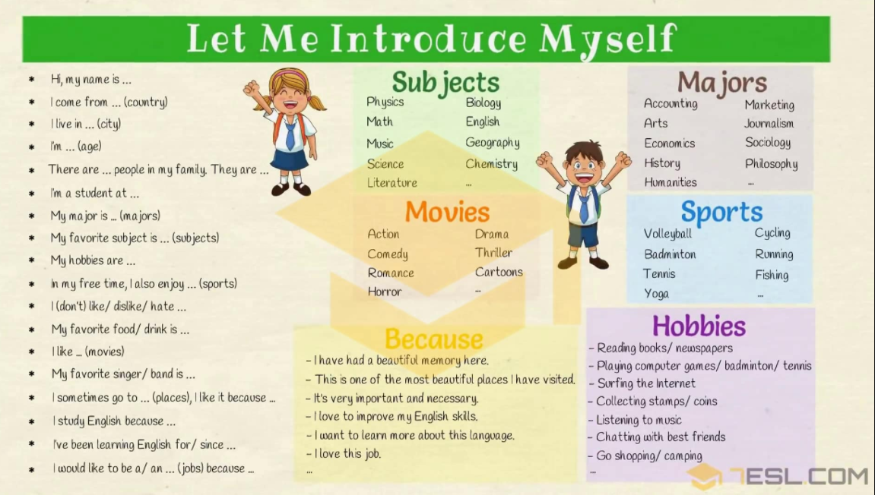

1. Study the table on introducing self and others

|  |  |  |
| --- | --- | --- |
| **TOPIC** | **QUESTIONS** | **ANSWERS** |
| **Introduce Yourself: Name** | **What’s your name?** | * My name is …/ I’m … * My full/ first/ last name is … * You can call me …/ They call me …/ Please call me …/ Everyone calls me … * My nick name is … |
| **Country** | **Where are you from?/ Where do you come from?**  **Where were you born?** | * I’m from …/ I hail from …/ I come from …/ My hometown is …/ I’m originally from … ([country](https://7esl.com/countries-nationalities-and-languages/)) * I’m … ([nationality](https://7esl.com/countries-nationalities-and-languages/)) * I was born in … |
| ****Address**** | **Where do you live?/ What’s your address?** | * I live in … / My address is … (city) * I live on … (name) street. * I live at … * I spent most of my life in … * I have lived in … for/ since … * I grew up in … |
| ****Age**** | **How old are you?** | * I’m … years old. * I’m … * I’m over/ almost/ nearly … * I am around your age. * I’m in my early twenties/ late thirties. |
| ****Family**** | **How many people are there in your**[**family**](https://7esl.com/members-of-the-family/)**?**  **Who do you live with?/ With whom do you live?**  **Do you have any sibling?** | * There are … (number) people in [my family](https://7esl.com/family-members-vocabulary-tree/). They are … * There are … (number) of us in my family. * My family has … (number) people. * I live with my … * I am the only child. * I don’t have any siblings. * I have … brothers and … (number) sister. |
| ****Birthday/ Phone number**** | **What is your date of birth?/ When is your birthday?**  **What is your phone number?** | * My birthday is on … * My phone number is … |
| ****Jobs**** | **What do you do?/ What do you do for living?/ What’s your**[**job**](https://7esl.com/jobs-and-occupations-vocabulary/)**?/ What sort of work do you do?/ What line of work are you in?**  **What did you want to be when you grew up?** | * I am a/ an … * I work as a/ an … * I work for (company) … as a/ an … * I’m unemployed./ I am out of work./ I have been made redundant./ I am between jobs. * I earn my living as a/ an … * I am looking for a job. / I am looking for work. * I’m retired. * I would like to be a/ an …/ I want to be a/ an … * I used to work as a/ an … at … (places) * I just started as … in the … department. * I work in/at a … (places) * I have been working in … (city) for … years. |
| ****Hobbies**** | **What’s your hobby?/ What do you like?/ What do you like to do?/ What’s your favorite … ?** | * I like/ love/ enjoy/ … (sports/ movies/ …/) * I am interested in … * I am good at … * My hobby is …/ I am interesting in … * My hobbies are …/ My hobby is … * My favorite sport is … * My favorite [color](https://7esl.com/colour-vocabulary/) is … * I have a passion for … * My favorite place is … * I sometimes go to … (places), I like it because … * I don’t like/ dislike/ hate … * My favorite [food/ drink](https://7esl.com/food-and-drinks-vocabulary/) is … * My favorite singer/ band is … * My favorite day of the week is … because …   **Because:**(self introduction sample)   * there are many things to see and do * This is one of the most beautiful places I have been visited. * I can relax there * it’s relaxing/ popular/ nice/ … |
| ****Education**** | **Where do you study?**  **What do you study? / What is your major?** | * I’m a student at … ([school](https://7esl.com/school-vocabulary-english/)) * I study at …/ I am at …/ I go to … (school) * I study … (majors) * My major is … |
| ****Marital status**** | **What is your marital status?**  **Are you married?**  **Do you have a boyfriend/ girlfriend?** | * I’m married/ single/ engaged/ divorced. * I’m not seeing/ dating anyone. * I’m not ready for a serious relationship. * I’m going out with a … (someone) * I’m in a relationship./ I’m in an open relationship. * It’s complicated. * I have a boyfriend/ girlfriend/ lover/ … * I’m in love with … (someone) * I’m going through a divorce. * I have a husband/ wife. * I’m a happily married man/ woman. * I have a happy/ unhappy marriage. * My wife/ husband and I, we’re separated. * I am available. * I haven’t found what I’m looking for. * I’m ready for a [rebound](https://en.wikipedia.org/wiki/Rebound_(dating)) relationship. * I’m a widow/ widower. * I’m still looking for the one. * I (don’t) have … (number) children. |
| ****Others**** | **Self introduction** | * I’ve got a … (pet) * I am a … person/ I’m … (character & personality) * My best quality is … (character & personality) * My best friend’s name is … * I (don’t) have … (number) international friends. * My dream is … |

. **USEFUL LINK**

Untuk Lebih jelasnya, silahkan buka link berikut:

Materi self introduction: <https://7esl.com/introduce-yourself/>

Video sample introduction: <https://www.youtube.com/watch?v=GdIESpzmqDo>

**TUGAS:**

* 1. **Silahkan membuat tulisan perkenalan diri dalam Bahasa Inggris yang meliput (pelajari ekspresi yang ada di dalam table):**
* Name
* Country/City
* Address
* Age
* Family
* Birthday/ Phone number
* Jobs
* Hobbies
* Education
* Marital status
* Others
  1. **Sample tulisan:**

*Hello my friends! Let me introduce myself. My name is Nadia Safira Rahma. You can call me Nadia. I am from Jakarta. I live in Karangjambe st. No 12, Bantul Yogyakarta. I am 18 years old. I have two brothers and one sister. I was born in Malang, 20 January 2002. My phone number is secret ^^. I am a student now. I study at STMIK AKAKOM Yogyakarta. My major is System Information. My hobby is watching Korean Drama. My favourite actor is Lee Min Ho. I like him because he is handsome. I am still single and have no boyfriend ^^. I am a happy and friendly person. I like to be friends with you all. See you all friends !!*

* 1. **Tulis perkenalan di atas beserta foto/video pada link:** <https://padlet.com/kuliahnafisa/48ll7wpwgismtfp0>
  2. **WAJIB tuliskan Nama Lengkap, NIM, dan Kelas pada judul postingan**.